Using the Uttlesford Engagement Portal
Use Google Chrome, Firefox or Apple Safari browsers for optimum performance
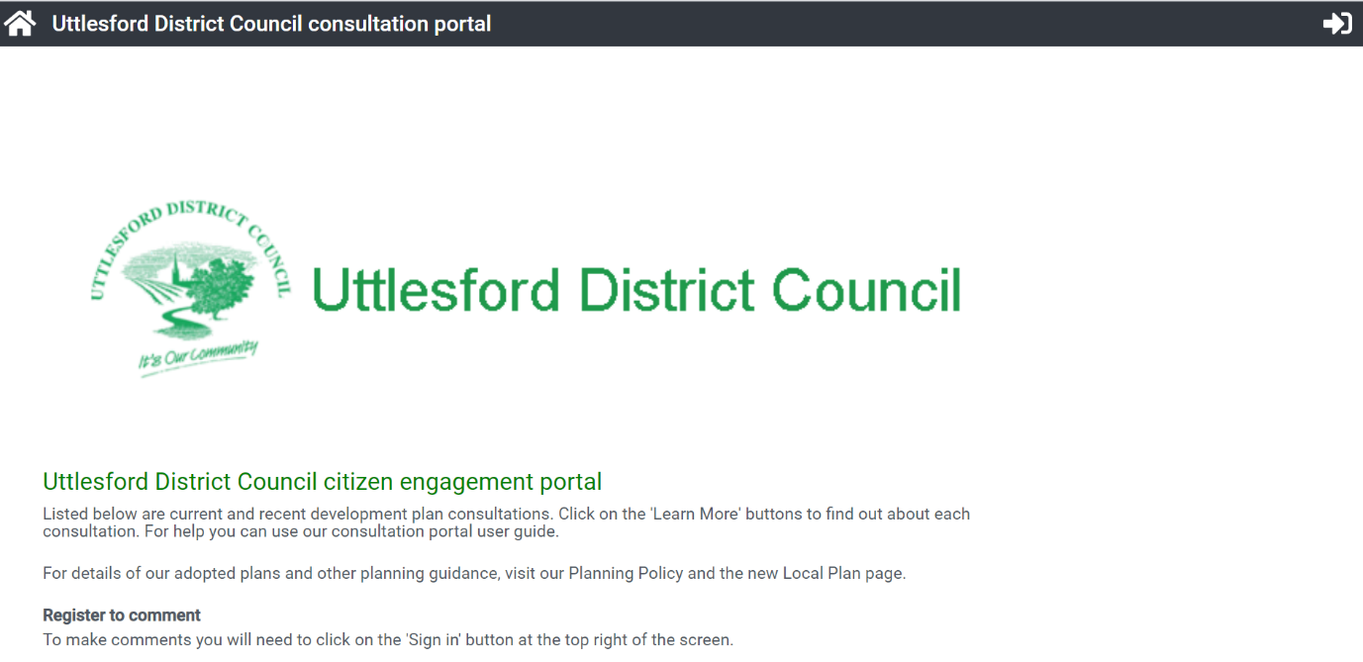
- Use the link from our Council website about the New Local Plan or go to https://uttlesford-consult.objective.co.uk/kse. These links will take you to this page:-

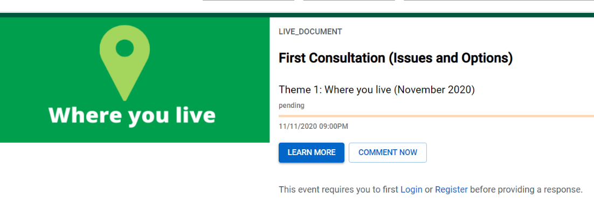
- On this page are links to the consultation documents. E.g.:
- The ‘Learn More’ button takes you to a page telling you about the purpose of this consultation.
The ‘Comment Now’ button takes you to the consultation document.
Having clicked on one of these buttons, you can move between each of these pages using the tabs ‘about this consultation’ and ‘proposal’ at the top of the page.
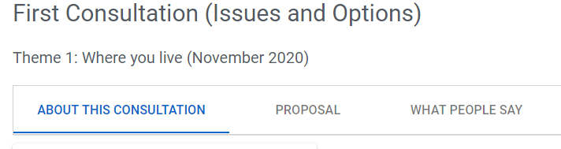

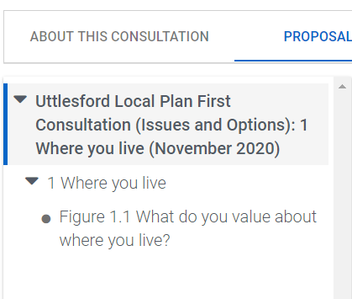
- On the Proposal page, use the index on the left to move around the document. (This is more useful on long documents).
- To respond to the question, you need to sign in or register.

- Sign in or register using this button on the top right of the screen.
If registering remember to make a note of your username and password.
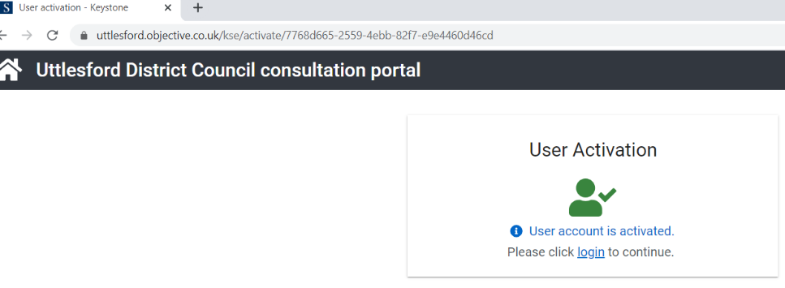
- If registering, you will receive an email with the subject ‘Your account on Uttlesford District Council’s consultation portal has been created. Click on the link in the email to activate your account. You will then be taken back to the portal. Click login as requested.

- Once registered and logged-in you will be able to submit your comments on a question.
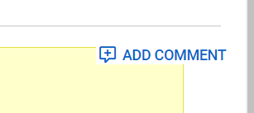
- To respond to the question, click on the tab ‘Add Comment’

Please note
- To avoid losing your comments use the Save draft button at the bottom of the page.
- When you click Complete comment, you have the chance to amend your comment by clicking ‘commented’ by the question box.
- Review and submit buttons are at the top of the page.
- You won’t be able to add any more comments to this submission after you click Submit.
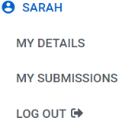
- Once logged in you can manage your account by clicking on your name in top right corner.

