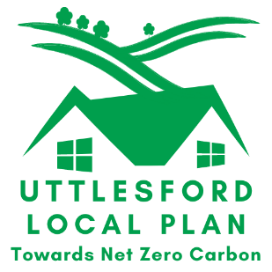
Theme 6: Biodiversity

Your Name

Organisation/Company Name
Your Address

Your Postcode
Your e-mail address*
*Please supply an e-mail address as this is the most efficient way for the Council to contact you about your comments and to let you know about the next stages in the preparation of the Local Plan
Your Telephone No.
If you are making comments on behalf of an organisation e.g. residents group or a client, please provide the name and address of the group or person you are representing in the box below.
Contact Name

Organisation/Company Name
Address

Postcode
e-mail address
Telephone No.

Please return your completed form to:
The Planning Policy Team, Uttlesford District Council, Council Offices, London Road, Saffron Walden, Essex CB11 4ER, or e-mail to localplan@uttlesford.gov.uk
Comments received before Wednesday 10 March 2021 will be summarised and presented back to the Community Stakeholder Forum. Comments received after this date up to the close of consultation at 5pm on 21 April 2021 will be brought together in a document summarising all comments received during the whole consultation exercise.
Need Help?
If you have any questions about the consultation or require help making your comments, please ‘phone 01799 510510 and ask for someone in the Planning Policy Team or e-mail the team using the e-mail address above.

Question: Thinking about the issues and questions raised in the diagrams below, use this page to tell us how we can create and enhance natural assets and biodiversity across the district. If you wish you can send us a photograph or image illustrating your response.
(If your response is more than 500 words please include a summary)

