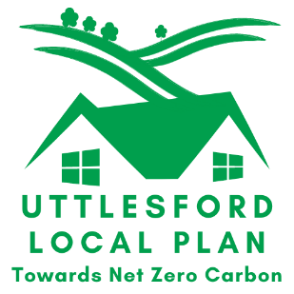
All themes/ Other comments

Your Name

Organisation/Company Name
Your Address

Your Postcode
Your e-mail address*
*Please supply an e-mail address as this is the most efficient way for the Council to contact you about your comments and to let you know about the next stages in the preparation of the Local Plan
Your Telephone No.
If you are making comments on behalf of an organisation e.g. residents group or a client, please provide the name and address of the group or person you are representing in the box below.
Contact Name

Organisation/Company Name
Address

Postcode
e-mail address
Telephone No.

Please return your completed form to:
The Planning Policy Team, Uttlesford District Council, Council Offices, London Road, Saffron Walden, Essex CB11 4ER, or e-mail to localplan@uttlesford.gov.uk
Comments must be received before the close of consultation at 5pm Wednesday 21 April 2021.
Need Help?
If you have any questions about the consultation or require help making your comments, please ‘phone 01799 510510 and ask for someone in the Planning Policy Team or e-mail the team using the e-mail address above.

Question: Thinking about the issues and questions raised in any/all of the consultation documents for the nine themes, please provide your comments below. The Council would also like to receive comments on issues that you think are relevant to the new Local Plan but have not been covered by the consultation themes.
(If your response is more than 500 words please include a summary of up to 500 words)

List of consultation questions

Theme 1: Where you live
What do you value about where you live and how would you like to see it improve in the future?

Theme 2: Character and heritage
Describe what you like about the character and heritage of Uttlesford, and how you would like to see this protected and enhanced whilst providing new sustainable communities

Theme 3: Climate change
Thinking about the issues and questions raised [in the consultation document], what actions need to be taken today to forestall the impacts of climate change?

Theme 4: Transport
Thinking about the issues and questions raised [in the consultation document], what options for sustainable transport in Uttlesford would you support?

Theme 5: Leisure, culture and healthy lifestyles
Thinking about the questions raised and the facts about Uttlesford [in the consultation document], tell us how existing places and new development can support health and wellbeing?

Theme 6: Biodiversity
Thinking about the issues and questions raised [in the consultation document] tell us how we can create and enhance natural assets and biodiversity across the district?

Theme 7: Local economy
Thinking about the issues and questions raised [in the consultation document] tell us how we can support sustainable business growth across the district?

Theme 8: Homes
Thinking about the issues and questions raised [in the consultation document] tell us what kind of housing should be built in Uttlesford in the next 20 years and beyond.

Theme 9: Creating new places and communities
What should new developments look like, what should they contain and where should they be located?

