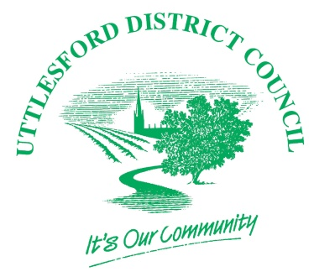
UTTLESFORD DISTRICT COUNCIL

LOCAL VALIDATION CHECKLIST FOR CERTIFICATE OF LAWFULNESS FOR PROPOSED USE OR OPERATION OR ACTIVITY

Uttlesford District Council Local Validation Checklist has been prepared in accordance with the Town and Country Planning (Development Management Procedure) (England) Order 2015 and the Town and Country Planning Act 1990 (as amended)

NATIONAL REQUIREMENTS | CORRESPONDING POLICIES & GUIDANCE | THRESHOLD
Application Form | Article 39 Town and Country Planning (Development Management Procedure)(England) Order 2015 | All applications
Fee | Article 39 Town and Country Planning (Development Management Procedure)(England) Order 2015 | All applications (where required)
A Plan | Article 39 Town and Country Planning (Development Management Procedure)(England) Order 2015  A plan identifying the land to which the application relates drawn to an identified scale, with North point (where the application specifies two or more uses/operations/other matters, plan must indicate land they relate to) | All applications
Evidence to verify the claim for a Certificate | Article 39 Town and Country Planning (Development Management Procedure)(England) Order 2015  Such EVIDENCE verifying the information in the application as the applicant can provide. | All applications
Statement | Article 39 Town and Country Planning (Development Management Procedure)(England) Order 2015  A statement of applicant’s interest in the land, name/address of others who have an interest and whether they have been notified of the application. | All applications
LOCAL REQUIREMENTS | CORRESPONDING POLICIES & GUIDANCE | THRESHOLD
There are no local requirements – the onus is on the applicant to provide as much detail as possible to substantiate their application.
Note:
All drawings must be suitable for scanning and display electronically. Please note that applications can be submitted electronically via the Planning Portal.

