MEETING OF THE UTTLESFORD HEALTH & WELLBEING BOARD – 6th February 2023

Committee Room, UDC Offices London Road Saffron Walden

Present:  Chair Marc Davis (Chair)  Rachel Lewis (Active Essex)  Kathleen Cunnea (ECFWS)  Esther Richards (Adult Social Care)  Clive Emmett & Sue Game (UCAN)  Craig McColl (Mind in West Essex)  Emily Bisley (Citizen’s Advice)  Cllr Maggie Sutton  Olivia Timotheou (WX Buddy Up Project) | Des Ashton (Uttlesford Foodbank)  Emili Shatchan (Essex Public Health)  Rachel Lewis (Active Essex) Kim Clarke (Social Prescriber)  Ian Tomkins (WXCCG) Mandy Cameron (NPCN) Donna Goodman (Carers First) Thomas Hardy (Saffron Hall) Mandy Goulee & Lee Welton (NHS)

Officers:  Dave Toombs (Senior Community Development)  Fleur Brookes (Safeguarding Officer)  Kerry Vinton (Partnerships Officer) | Apologies:  Alison Wilson (Mind in West Essex)  Kate Robson (Citizen’s Advice)  Ros Sonderskov (Alzheimer’s Society)  Marcus Watts (Environmental Public Health, UDC)  Fiona Gardiner (Communities, Health & Wellbeing Manager) Julie Allix (HCRG Care Grp)  Angus Henderson (PCT)  Lois Bowers (Local Plan-seconded from ECC)

H&WB1 NOTE OF THE LAST MEETING 6th February 2023

Minutes agreed as accurate, action picked up during the course of the meeting.

H&WB2 UPDATE ON PRIORITY LEADS

As a result of the refreshed Health & Wellbeing Strategy the priorities now need to translate into actions.

Priority 1: Improve and support mental wellbeing – Craig McColl, Mind in West Essex

Mental Health Transformation work progressing well, the new teams were meeting regularly -coaches and practitioners have full caseloads

Sanctuary now available in Uttlesford on a Thursday evening SW High Street 4pm -11pm.
Night Owls – emotional support service, people must be registered prior to using the service https://www.mindinwestessex.org.uk/services/west-essex-night-owls-support-line/

The aim of the additional programmes was to keep those who had become unwell, in their own homes and recovering.

The Chair reported on the Happiness Institute https://www.happinessresearchinstitute.com/

Mind in West Essex in partnership with UCAN provided digital kit, including sim cards, training and kit, increasing access to on-line support.

There was interest in exploring early intervention/proactive protection and the maintenance of good mental health.

Priority 2: Enable people to live healthy, active lifestyles throughout their lives - Rachel Lewis

It was agreed to rebrand Active Uttlesford - Find Your Active Uttlesford

Ride London coming through the district from 26th-28th May 2023

Project funding resulted in 39 applications to the Find Your Active Small Grants pot, with 20 being successful. 2 focus on older residents, 7 on Children and Young People, 3 on disability or long term health conditions, 5 women and girls, 1 from lower-socio economic groups, 2 on the cost of living crisis - £27, 267.08 approved spend in Uttlesford
Great range of physical activities included, especially from non-traditional sporting clubs like snooker and fly fishing.

Access was still a challenge, an internal Active Essex conversation would be had regarding transport going forward.

SWCHS/Jackie Coles galvanising all primary school get their active travel network plans – Impact video can be made available to the board.

Uttlesford Strength & Balance classes would continue for another 3yrs, this included the additional transition classes – due to vacancy, a plea was made for anyone who knew of any instructor who may be interested in get involved in the delivery of the classes.

North Uttlesford GPs had identified some funding, with the aim to get match funding would look to develop some concept promotion on health lifestyles via social media, email or texting targeted patients groups directly.

Uttlesford would be providing Short Breaks for SEN families, the challenged had been to find suitable delivery providers.

Priority 3: Build healthy, resilient, active communities – Lois Bowser

Priority 4: Alleviate pressures associated with increased costs of living – Emily Bisley, Uttlesford Citizen’s Advice

With the weather improving and talk of a slowing inflation - it's easy to fall into the rhetoric that we are over the worst - however from a CA perspective and we assume revs and bens in the Council - it does feel very different. We are still extremely busy - 15% increase in unique clients since January and we are really just waiting to see the gradual shift in households from a situation where their finances are precarious (using charitable support/ taking on extra jobs more hours) to moving into structural debt problems and housing rent/ mortgage arrears.

With the support of Uttlesford Foodbank and various other funding pots - we have just recruited 2 FTE posts and are still recruiting for another part-time role - trying to help us cope with demand around debt/ cold homes and the day to day pressure on the phones.

There continues to be good joint working between all partners working in this area - but any help to continue to promote benefit uptake and encouraging people to reach out for support is going to be vital. Debt and mental ill-health often go hand in hand - so getting the message out that there is help available is really important.

Also:

CA are waiting for details on the Essex Hardship Fund
CA have access to Fuel Bank Foundation Energy Vouchers for clients on Prepayment meters - through Energy Redress Funding.
CA are currently using funding from Councillors and a local fundraising effort - £6400 remaining.
CA will need to consider fundraising later in the year depending on the outcome of the Essex Hardship Fund.

The information below refers to update of the ECC Healthy Start Vouchers, made available from Emili Shatchan, Senior Wellbeing & Public Health Officer

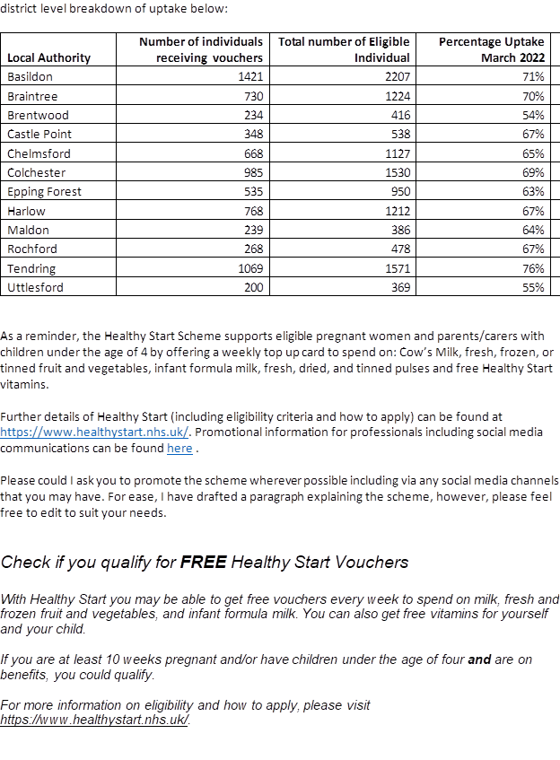

Priority 5: Improve access to services and facilities – Clive Emmett, UCAN

Clive Emmett invited those interested in joining a subgroup to work collaboratively on the cross-cutting activities around the Improve access to services and facilities priority in order to support the monitoring and performance of the priorities within the H&WB Strategy to consider.

A new programme of activities had started at the Jubilee Community Hub in Saffron Walden, further consultation on what the public would like delivered at the hub will start shortly.

Mobile Community Hub to visit parishes & hamlets, with support from partner agencies, this was in cooperation with the Housing Tenants trailer already delivering a similar service around the district.

A step-by-step guide to how to register for an on-line NHS account had been, copies were distributed around board members.

Citizen’s Advice provided the follow Frontline Report.

H&WB6 BUDDY UP PROJECT UPDATE – Olivia Timotheou, Epping Forest DC
It was suggested the project could be promoted by the H&WB Coaches and PCN Learning Disability Champions.
It was agreed a future agenda item for the board was to look at the value of volunteers.
H&WB7 TOGETHER IN SOUND – Thomas Hardy
H&WB8 WEST ESSEX VIRTUAL HOSPITAL - Lesley Hanks
Action: Clive Emmett and Lesley Hanks to link regarding the Ticket Home Service
H&WB9 H & WB BUDGET
Action: Dave Toombs to draft a budget update and circulate to the board.

H&WB10 AOB

UCAN to share report on Sudanese Hub and lessons learned in terms of the humanitarian response. Thanks went to all volunteers and agencies who support the refugees fleeing their homes, some in life threatening circumstances.

Social Prescribing team continues to grow, 3 in the North and 3 in the South of the district, with one to specialise on children & Young People.

Dave Toombs thanked Marc Davis for chairing the board through a particularly challenging 4years, he would now to take forward the process of rotation for the next Health & Wellbeing Board Chair.

Meeting dates 2023

- 27th September 2023
10am – 12noon Committee Room, UDC Offices, London Road, Saffron Walden CB11 4ER

