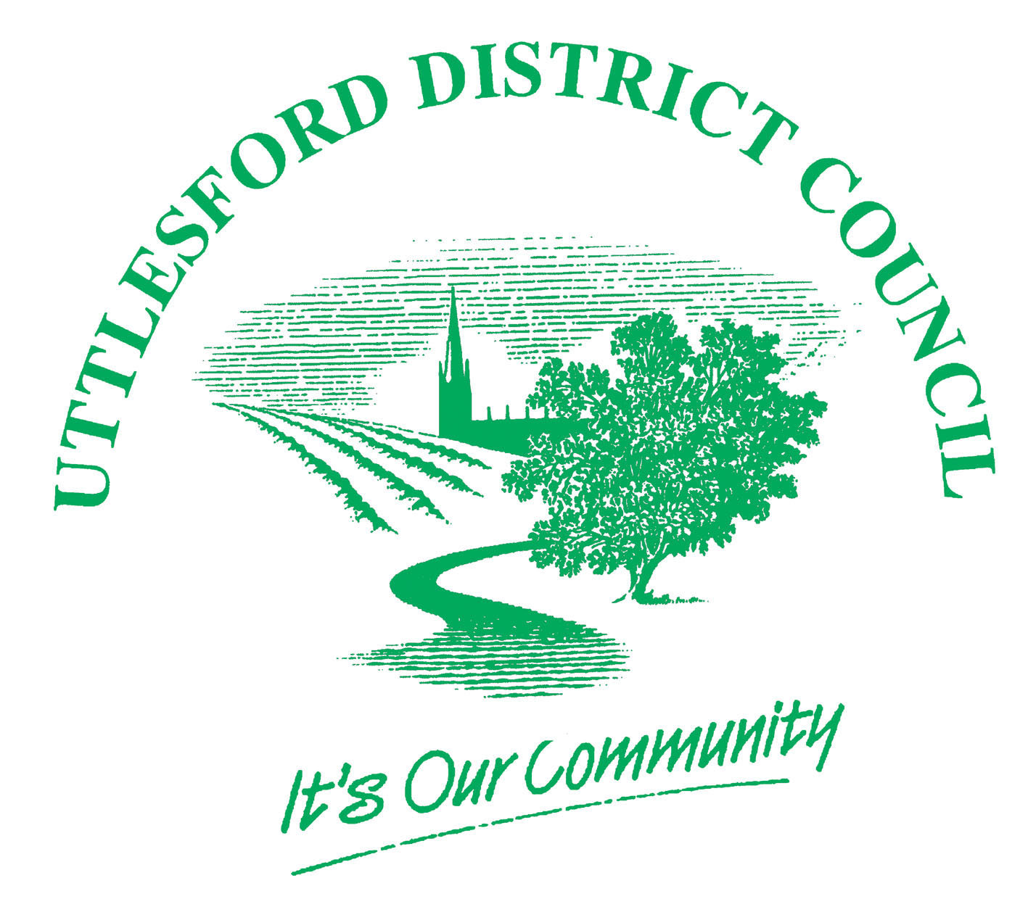
Uttlesford District Council

Form for a developer to notify the local planning authority (LPA) of the completion of the development:
(i.e. the process set out by condition A.4 of Schedule 2 Part 1 Class A of the GPDO 1995, as amended)

PLEASE READ THE FOLLOWING INSTRUCTIONS FIRST

Before completing this form please read the guidance notes at the end of the form.
If you are completing this form by hand please write legibly in block capitals. In all cases ensure that your answers are inside the boxes and written or typed in black ink. Use additional sheets if necessary.
You may wish to keep a copy of the completed form for your records.

What is the address of the development (including postcode):

What was the date of completion of the development:

What is your name: (i.e. as the developer)

What is your contact address: (if different from the address of the development)

What is your email address: (if you are content to receive communications electronically)

What reference number did the LPA give you when you notified them before beginning this development:

Important Notes for Developers:
- This form is optional, as the legislation does not require that you submit a form. However, this form has been designed to help ensure that you provide the LPA with the information required by the legislation.
- When you notified the LPA before beginning this development, if you received a written notice that prior approval was not required, or a written notice that prior approval was given, then it would be helpful if you could please include a copy of this written notice when you submit this form.

